

**SEND Provision at Wath Central Primary School**

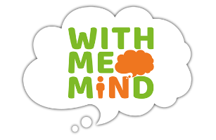

***@WCP*** *We value every child for who they are and prepare them for everything they could be.*

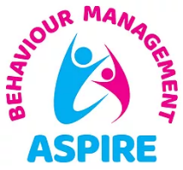





***School Staff Expertise***

* *SENDCo*
* *School SEND Team (with expertise in EHCP’s and SALT)*
* *Pastoral Lead & Safeguarding Team*
* *Learning Mentor*
* *Emotional Literacy Champion*
* *Inclusion Hub Strategic & Operational Lead*
* *Senior Lead for Mental Health*
* *PremAware Champion*
* *Staff skilled in the delivery of speech and language programmes*
* *Staff skilled in the delivery of speech and language screening.*
* *Staff skilled in supporting autism and neurodiversity.*
* *Staff skilled in supporting children with medical needs.*
* *Team Teach trained team*
* *Two Autism Education Trust Trainers*
* *Trauma Informed Champion*
* *Bonding Through Play Champion*
* *Trauma Informed teachers and support staff*
* *Sports Coach*
* *WMIM Liaison*
* *Prem Aware Trained Staff*
* *Asthma Friendly School Trained staff.*
* *Voice (Oracy) 21 Project Team*
* *Attendance Champion*





At Wath Central we are passionate about providing the best possible education for all of our pupils, including those with additional needs, to enable them to reach their true potential and develop as individuals.

We aim to reduce barriers to learning and are committed to providing opportunities and support to enable pupils with SEND to successfully access a real and meaningful curriculum appropriate to their needs. Children’s mental health and wellbeing is paramount.

Our approach offers a range of opportunities for children to engage with activities and experiences, giving them the social and emotional skills to do well at school both socially and academically. We equip them with skills to develop their resilience and their capacity to deal more confidently with the trials and tribulations of life.

Wath Central Primary School has a high level of children accessing SEND Support within school. 21% of children in school are accessing this at SEN Support level (compared to 14% nationally) and 5% accessing this support by EHCP’s (compared to 4.8% nationally). In addition to this, we have a further 11% of students being supported through Quality First Teaching, Wave 1 interventions and One Page Profiles. We currently have 14 children currently being assessed for EHCPs and between 10 - 15 potentially on the EHC pathway.

We have a number of children in our school who have complex SEND needs, and a result, we have design two additional curriculum pathways to support both our pre-formal (Explore) and semi-formal (Discover) pathways. This sits alongside our usual curriculum pathway (Connect.) Our highest primary area of SEND need in school is *‘Communication and Interaction’ and 28% of student within our school have SEMH needs.*

Pupil Premium of 17% (compared to 23% nationally) which for a variety of reasons does not necessarily reflect our current demographic. The school’s catchment is socio-economically diverse with deprivation indicators for Health, Crime and Employment all in the lowest 20% nationally.

**Together, we can**

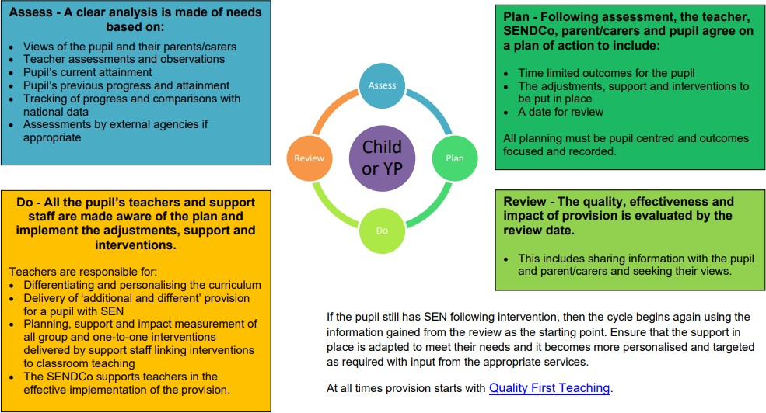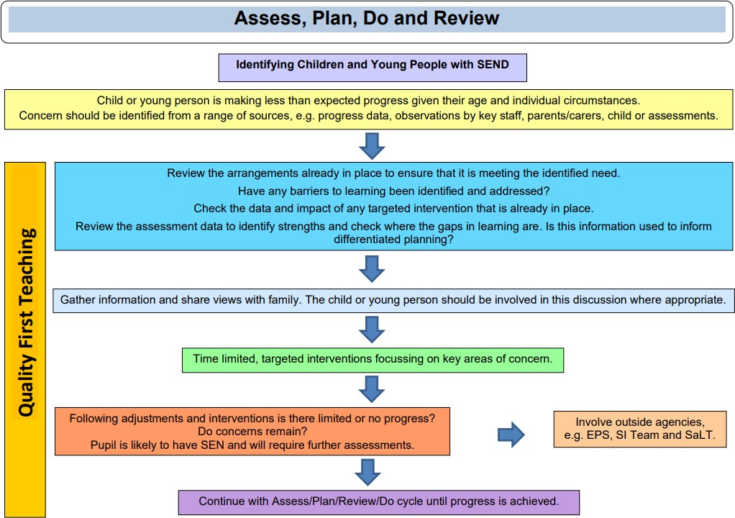

***Intent****: As a school, we want our children to have a strong sense of identity and belonging. We want them to be empowered with the knowledge, skills and confidence to be able to make an impact on the future by understanding the past and the world they inherit. In order to do this, we strive to develop in them a curiosity for the world in which they live, a love of learning and be able to work collaboratively whilst expressing their individuality with confidence. In this way, we deliver an enquiry curriculum that encourages our learners and staff to question the purpose of the learning and develop meaningful projects which will have an impact on the world around us.*

*We value every child for who they are and prepare them for everything they could be.* ***Our living values are: Respect. Responsibility. Resilience.***

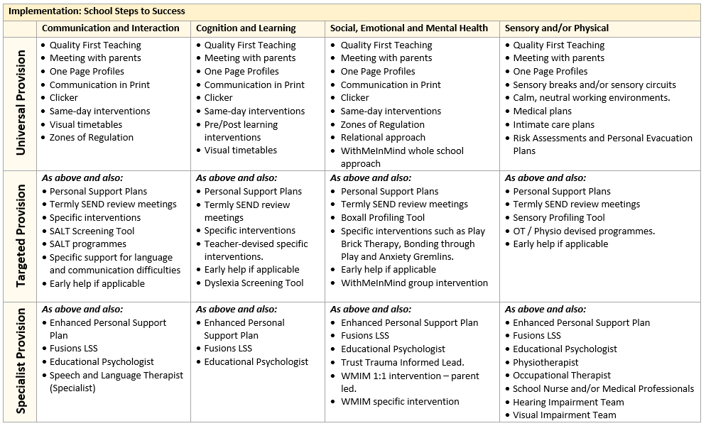

**Impact:** As a result, children at Wath Central will:

* feel happy, safe and respected.
* behave appropriately and have the relevant tools (and support) to regulate their emotions
* have their diversity celebrated.
* demonstrate high levels of engagement in activities, developing their speaking, listening and social skills.
* have supportive and trained staff who make appropriate provision for the child’s individual needs.
* make good progress from their starting points due to Quality First Teaching and to the use of resources and bespoke small group intervention which meets the needs of the pupils – especially children with SEND.
* leaving our school having developed good independence and life skills.
* make secure transitions between classes and educational providers e.g. EYFS or High School.

**So far this year staff have received CPD in these areas of SEND:**

* Trauma Informed Schools – Whole School Training.
* Cerebral Visual Impairment Training.
* Grief and Loss Training.
* Supporting children with literacy difficulties (including Dyslexia.)
* Embedding Language Development Approaches in Learning in EY and KS1.
* Embedding Language Development Approaches in Learning in KS2
* Colourful Semantics in EY and KS1.
* Use of Colourful Semantics and Shape Coding in KS2.
* Supporting children with Diabetes
* Emotion Coaching and supporting Behaviour as Communication *(planned)*
* Trauma Informed Schools – SLT Training *(planned)*

**Last year staff received CPD in these areas:**

* Autism
* ADHD
* Inquiry Based Learning
* Attention Autism
* Makaton
* Clicker8
* Attention Autism
* Clicker8
* Prem Aware
* Sensory Circuits
* Supporting a child with Gastrofeeding
* Asthma Awareness

|  |  |  |  |  |
| --- | --- | --- | --- | --- |
| **Implementation: School Steps to Success** | | | | |
|  | **Communication and Interaction** | **Cognition and Learning** | **Social, Emotional and Mental Health** | **Sensory and/or Physical** |
| **Universal Provision** | * Quality First Teaching * Meeting with parents * One Page Profiles * Communication in Print * Clicker * Same-day interventions * Visual timetables * Zones of Regulation | * Quality First Teaching * Meeting with parents * One Page Profiles * Communication in Print * Clicker * Same-day interventions * Pre/Post learning interventions * Visual timetables | * Quality First Teaching * Meeting with parents * One Page Profiles * Communication in Print * Clicker * Same-day interventions * Zones of Regulation * Relational approach * WithMeInMind whole school approach | * Quality First Teaching * Meeting with parents * One Page Profiles * Sensory breaks and/or sensory circuits * Calm, neutral working environments. * Medical plans * Intimate care plans * Risk Assessments and Personal Evacuation Plans |
| **Targeted Provision** | ***As above and also:***   * Personal Support Plans * Termly SEND review meetings * Specific interventions * SALT Screening Tool * SALT programmes * Specific support for language and communication difficulties * Early help if applicable | ***As above and also:***   * Personal Support Plans * Termly SEND review meetings * Specific interventions * Teacher-devised specific interventions. * Early help if applicable * Dyslexia Screening Tool | ***As above and also:***   * Personal Support Plans * Termly SEND review meetings * Boxall Profiling Tool * Specific interventions such as Play Brick Therapy, Bonding through Play and Anxiety Gremlins. * Early help if applicable * WithMeInMind group intervention | ***As above and also:***   * Personal Support Plans * Termly SEND review meetings * Sensory Profiling Tool * OT / Physio devised programmes. * Early help if applicable |
| **Specialist Provision** | ***As above and also:***   * Enhanced Personal Support Plan * Fusions LSS * Educational Psychologist * Speech and Language Therapist (Specialist) | ***As above and also:***   * Enhanced Personal Support Plan * Fusions LSS * Educational Psychologist | ***As above and also:***   * Enhanced Personal Support Plan * Fusions LSS * Educational Psychologist * Trust Trauma Informed Lead. * WMIM 1:1 intervention – parent led. * WMIM specific intervention | ***As above and also:***   * Enhanced Personal Support Plan * Fusions LSS * Educational Psychologist * Physiotherapist * Occupational Therapist * School Nurse and/or Medical Professionals * Hearing Impairment Team * Visual Impairment Team |

